Tags are utilised on the CBESS project to convey information about a particular situation or task as shown below.
All sections of tags shall be completed and signed by the relevant person before deemed valid
TAG TYPE | TAG USAGE
BOUNDARY ISOLATION TAG | - Must be placed in conjunction with a boundary isolation lock  - Must also be placed on adjacent disconnected equipment, tag details must match on both sides.  - Can only be placed or removed by a Personal Isolation Officer  - Can only be removed once the equipment isolated is cleared for energisation by an authorised isolation officer  - Removing a boundary isolation tag that is not attached to a boundary isolation lock is considered a serious breach of procedure.
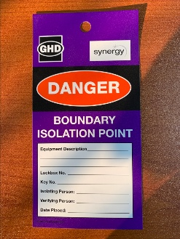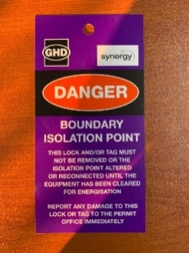
PERSONAL DANGER TAG | - Used for personal & permit isolations (Unless lock number is registered on permit)  - Placed on a personal isolation lock by a lock holder before lock is attached to an isolation point or lockout device  - Only the person who placed the lock/tag is authorized to remove it, unless exceptional circumstances apply
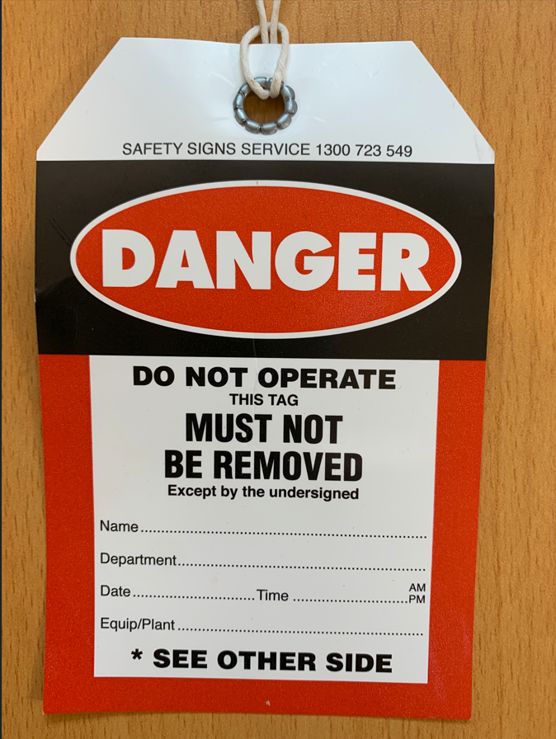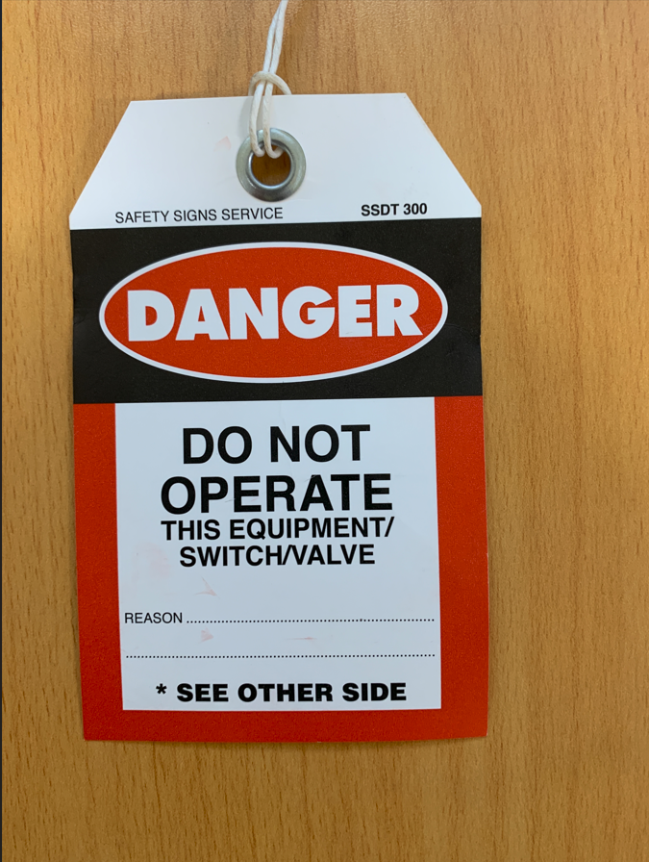
COMMISSIONING AND TESTING TAG | - Used to identify areas or equipment that are under commissioning control  - Must be used in conjunction with a commissioning lock when placing and verifying simple isolations.  - Electrical equipment may be identified by a Commissioning in Progress adhesive label, which shall be the same design as the tag.  - Equipment must not be operated and / or the tag removed without permission from the commissioning manager or authorised nominee
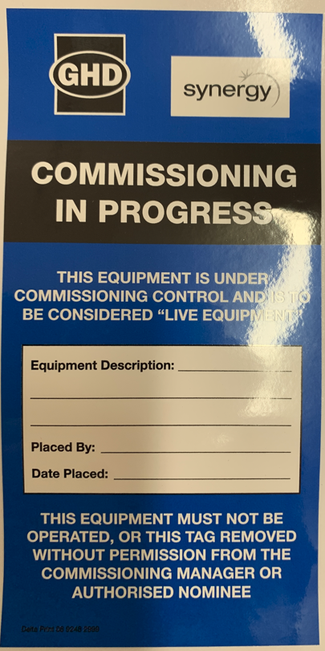
ISOLATION TAG | - Used to identify a particular isolation point  - Can only be placed and removed by an Authorised Isolation Officer  - Proof that equipment isolation has been carried out  - Must not be removed whilst personal danger tags are present
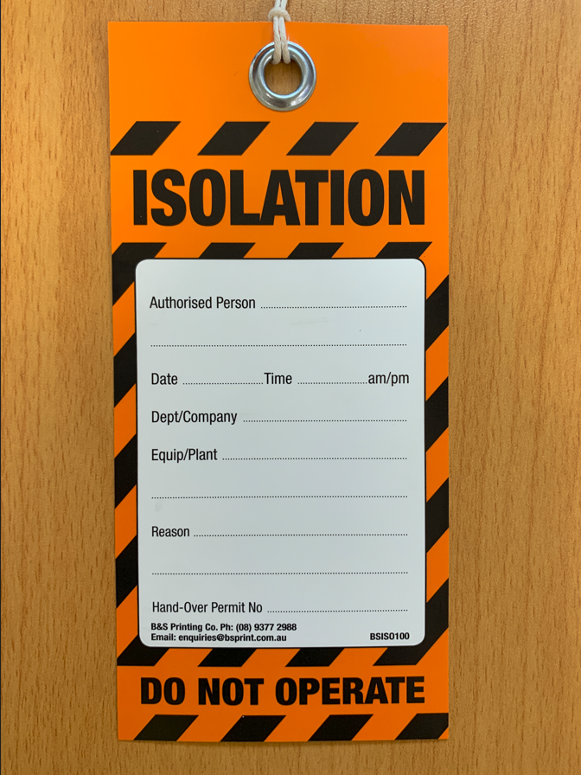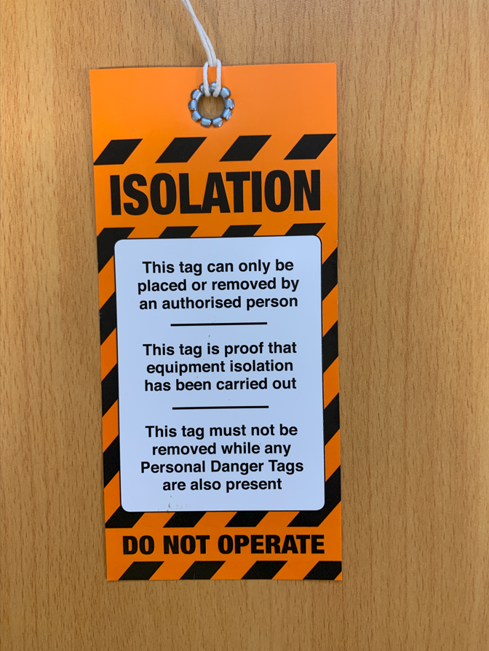
OUT OF SERVICE TAG | - Used to identify faulty equipment  - Can be placed by any personnel  - Can only be removed by an authorised repair agent once repairs are underway or have been completed
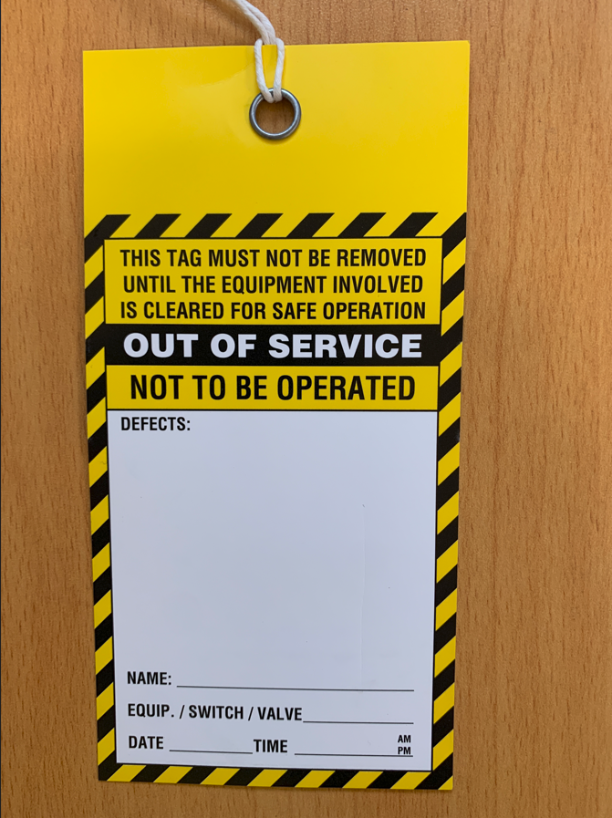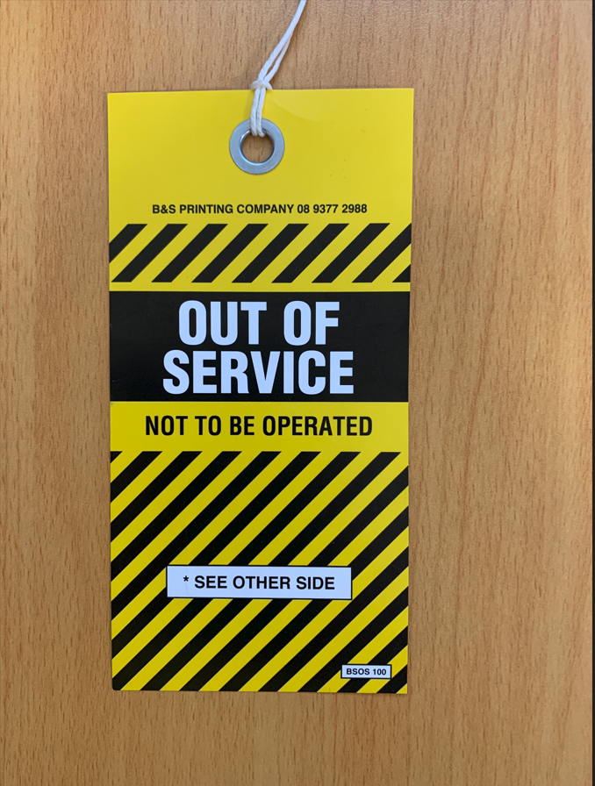
INFORMATION TAG | - Used to convey general information regarding a particular area or task such as the reason for barricading or an identified hazard  - Can be placed and removed by any personnel involved with the task in question  - Information shall be updated as required and tag shall be removed when the information displayed is no longer valid
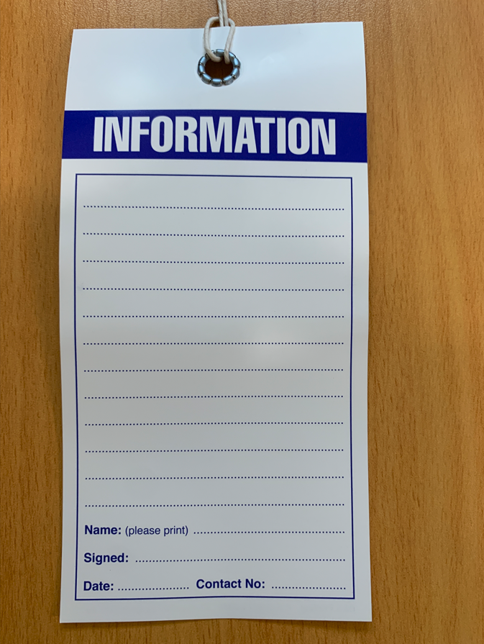

Once tag is no longer required the tag is to be torn in half and disposed of in a correct manner

